

Practices for Secure Software Report

Table of Contents
Document Revision History 3
Client 3
Instructions 3
Developer 4
1. Algorithm Cipher 4
2. Certificate Generation 4
3. Deploy Cipher 4
4. Secure Communications 4
5. Secondary Testing 4
6. Functional Testing 4
7. Summary 4
8. Industry Standard Best Practices 4

Document Revision History

Version | Date | Author | Comments
1.0 | 04/19/2026 | Abishake Shanker

Client



Instructions

Submit this completed practices for secure software report. Replace the bracketed text with the relevant information. You must document your process for writing secure communications and refactoring code that complies with software security testing protocols.

- Respond to the steps outlined below and include your findings.
- Respond using your own words. You may also choose to include images or supporting materials. If you include them, make certain to insert them in all the relevant locations in the document.
- Refer to the Project Two Guidelines and Rubric for more detailed instructions about each section of the template.

Developer
Abishake Shanker

Algorithm Cipher

The algorithm chosen for this project is SHA-256. SHA stands for Secure Hash Algorithm and the 256 refers to the size of the output it creates. SHA-256 is part of the SHA-2 family which was created by the National Security Agency and approved by the National Institute of Standards and Technology in 2001.

SHA-256 takes any input and turns it into a fixed 256-bit string of characters. This output is called a hash or checksum. The same input will always produce the same hash. If even one character in the input changes the hash will look completely different. This makes it easy to check if data has been changed or tampered with.

SHA-256 is a one-way function. That means you can create a hash from data but you cannot use the hash to get the original data back. This is different from encryption where data can be decoded with a key. SHA-256 does not use keys at all. It is only used to verify that data has not changed.

Older hash algorithms like MD5 and SHA-1 are no longer considered safe. MD5 has a 128-bit output and SHA-1 has a 160-bit output. Both have known weaknesses that allow attackers to create fake matching hashes. SHA-256 with its 256-bit output is much stronger and is the current standard used in websites and security systems around the world.

For the HTTPS connection in this project the server also uses an RSA key pair. RSA is an asymmetric key system which means it uses two keys: one public and one private. The public key is shared with anyone and the private key is kept secret. This key pair is stored in a keystore file and is used to set up the secure connection before any data is sent.

Certificate Generation

A self-signed certificate was created using the Java Keytool program. This certificate tells the browser that the server is who it says it is and allows the HTTPS connection to work. The following command was used to create the certificate:

keytool -genkeypair -alias artemis -keyalg RSA -keysize 2048 -storetype PKCS12
-keystore src/main/resources/keystore.p12 -validity 3650 -storepass Biswa123
-keypass Biswa123 -dname "CN=Abishake Shanker, OU=SNHU, O=SNHU, L=Manchester, ST=New Hampshire, C=US"
-sigalg SHA256withRSA -ext "BasicConstraints=ca:true" -J-Dkeystore.pkcs12.legacy

The certificate was then exported as a CER file using this command:

keytool -export -alias artemis -keystore src/main/resources/keystore.p12 -rfc -file src/main/resources/artemis.cer

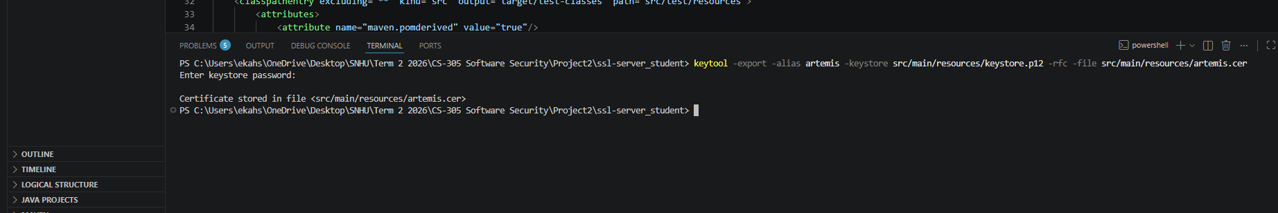

Deploy Cipher

The screenshot below shows the /hash endpoint running on the server. The SHA-256 algorithm takes the input string "Hello World Abishake Shanker" and produces a unique checksum. This checksum can be used to verify that the data has not been changed.
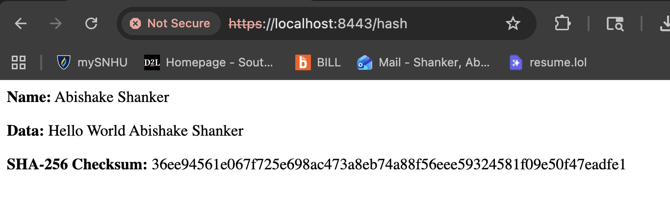

Secure Communications
The screenshot below shows the application running on port 8443 using HTTPS. The URL bar shows https://localhost:8443/hash which confirms that the server is using SSL to encrypt the connection. The browser displays a Not Secure warning because the certificate is self-signed which is expected in a development environment. In a real production environment a certificate from a trusted authority would be used instead.


Secondary Testing
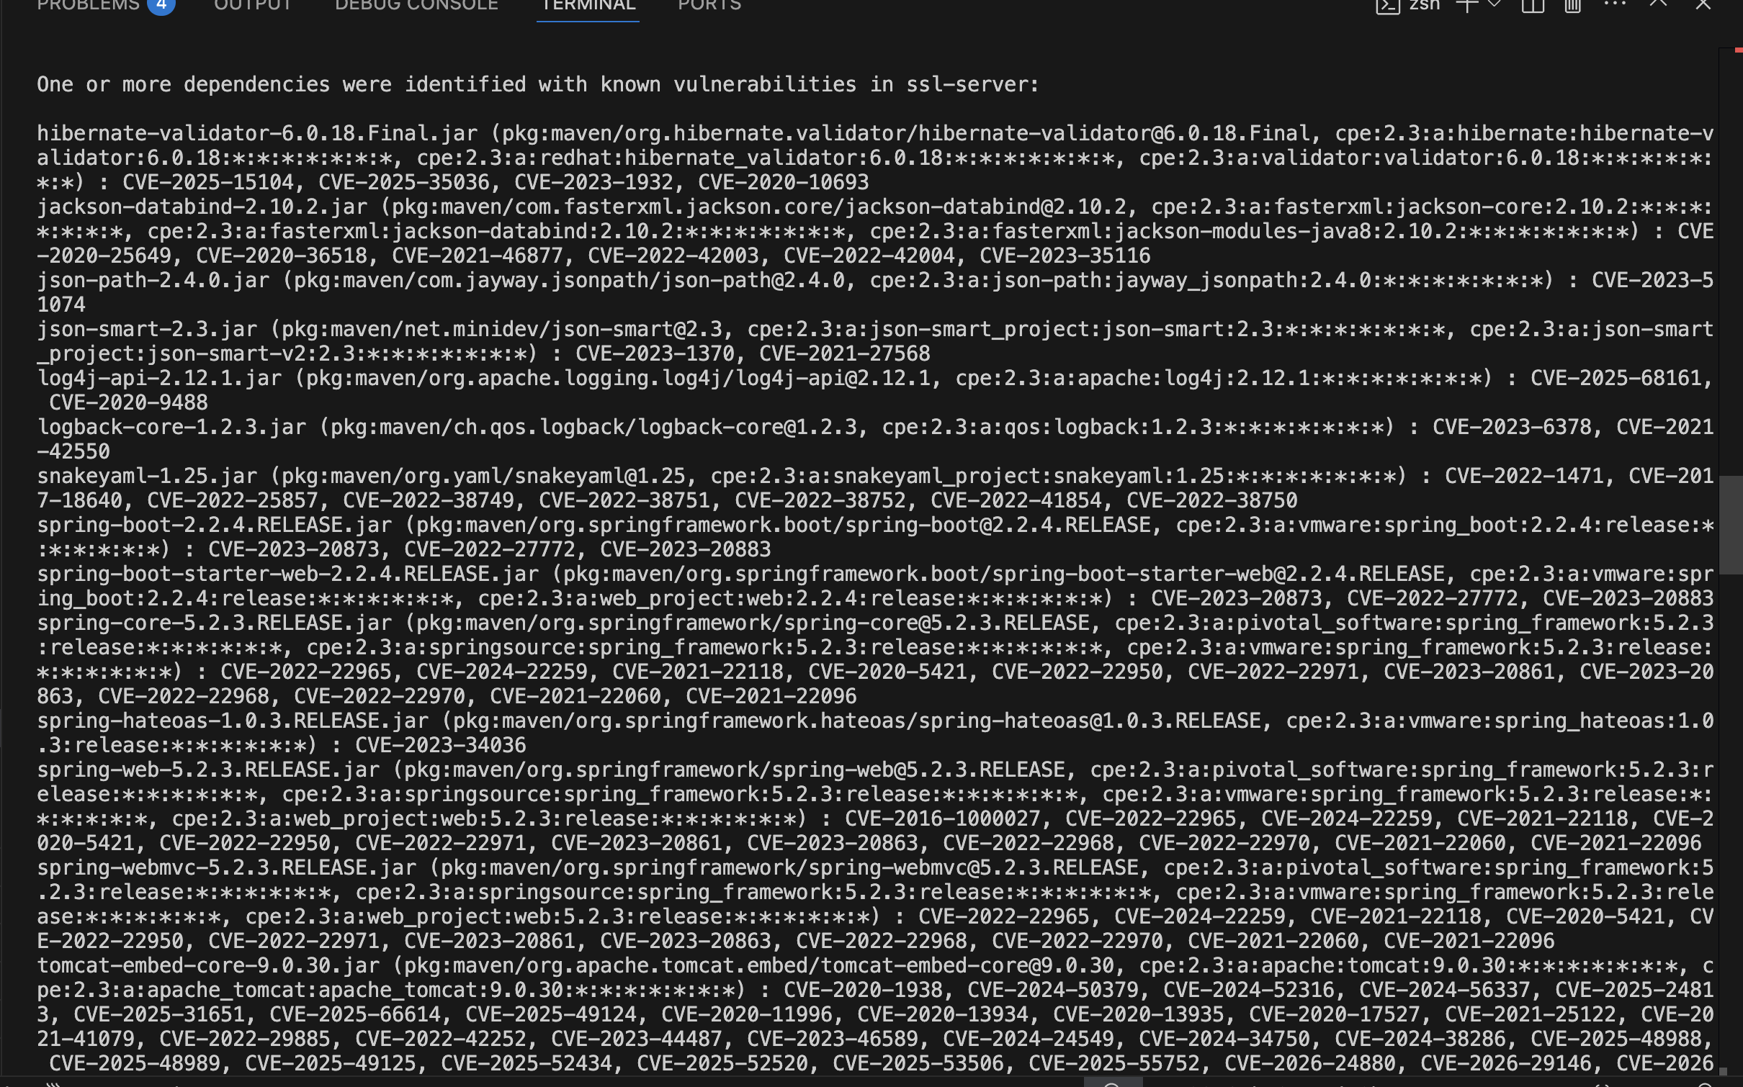
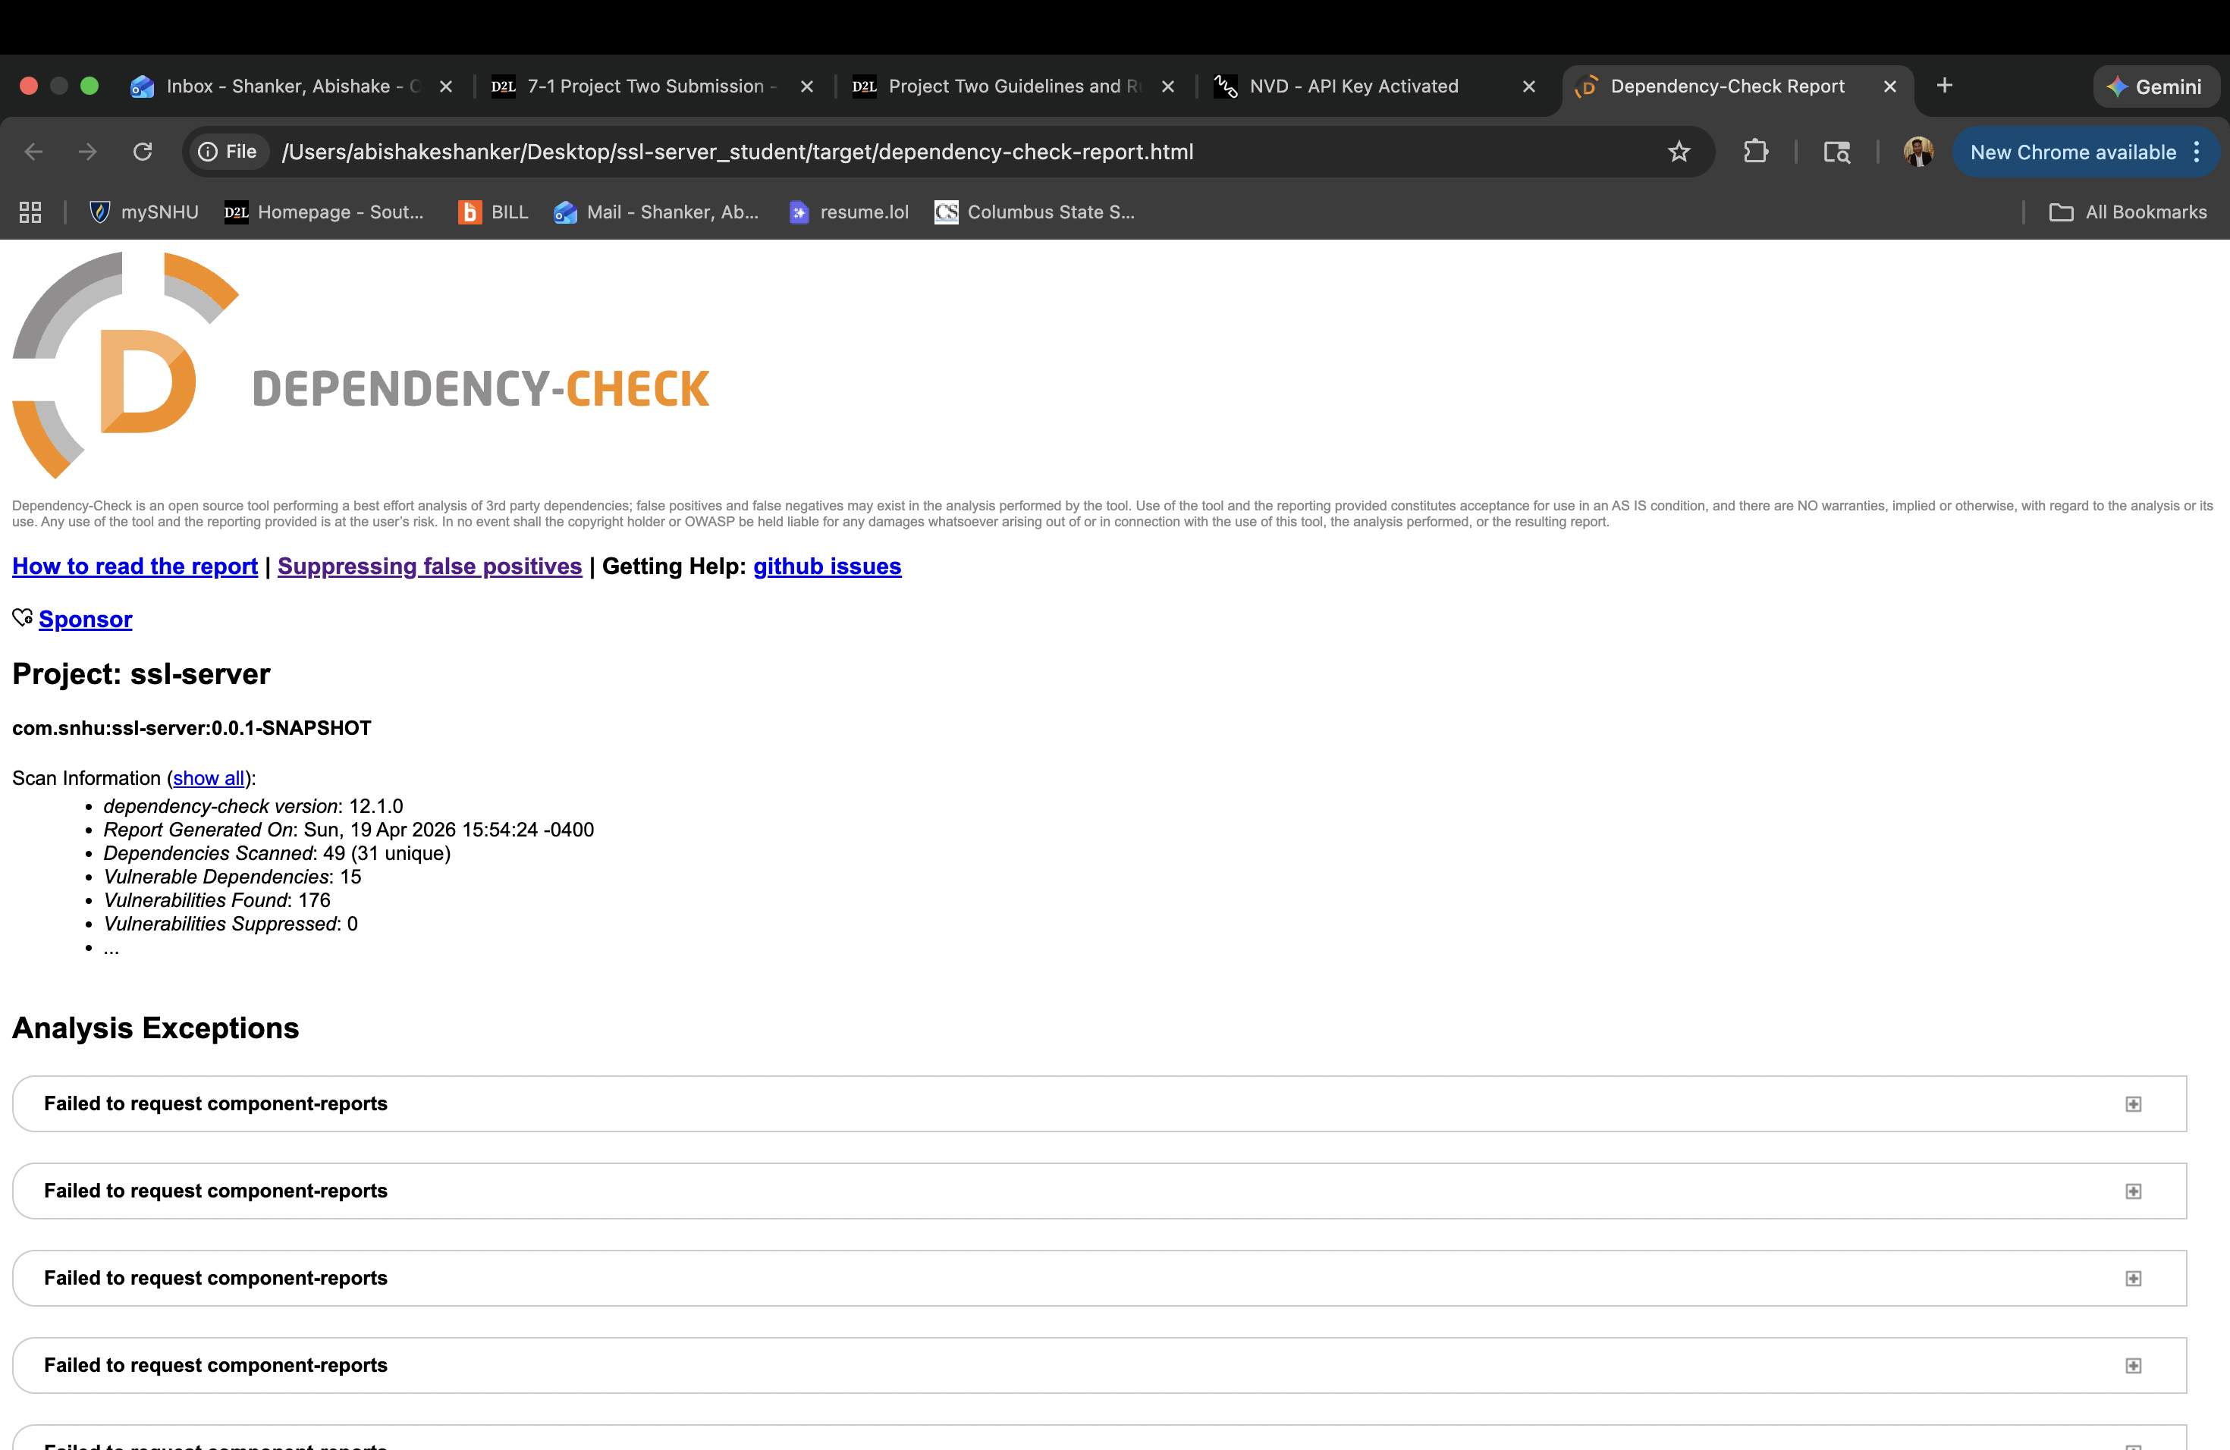

Functional Testing

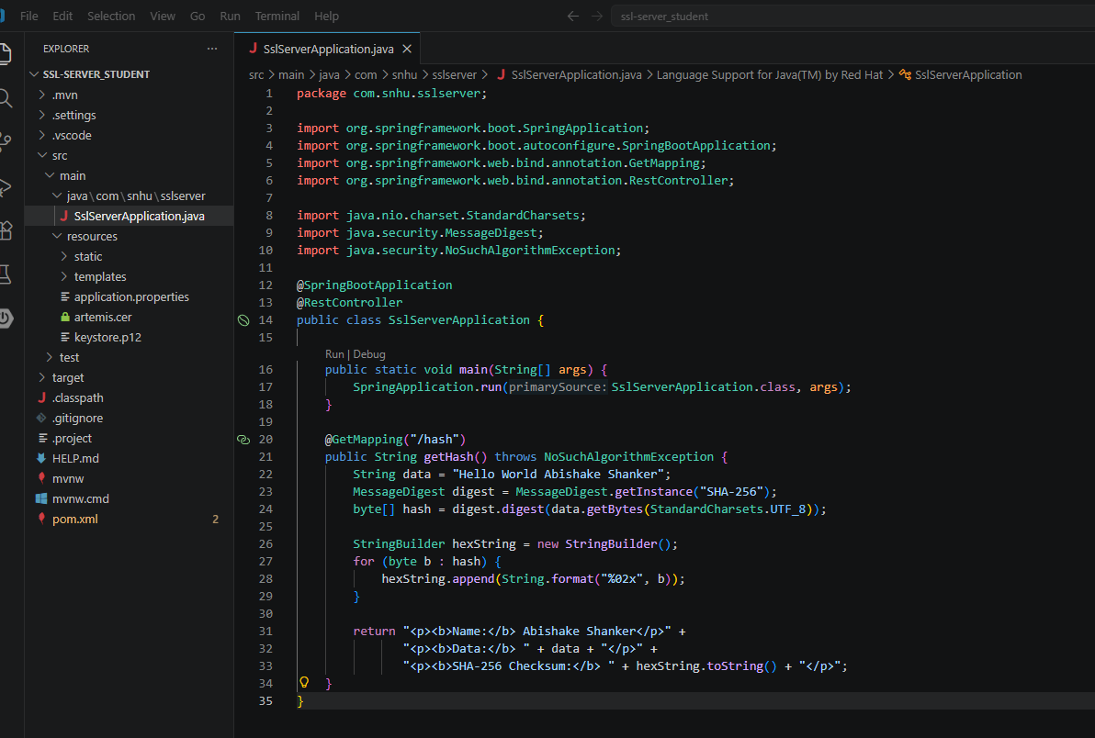
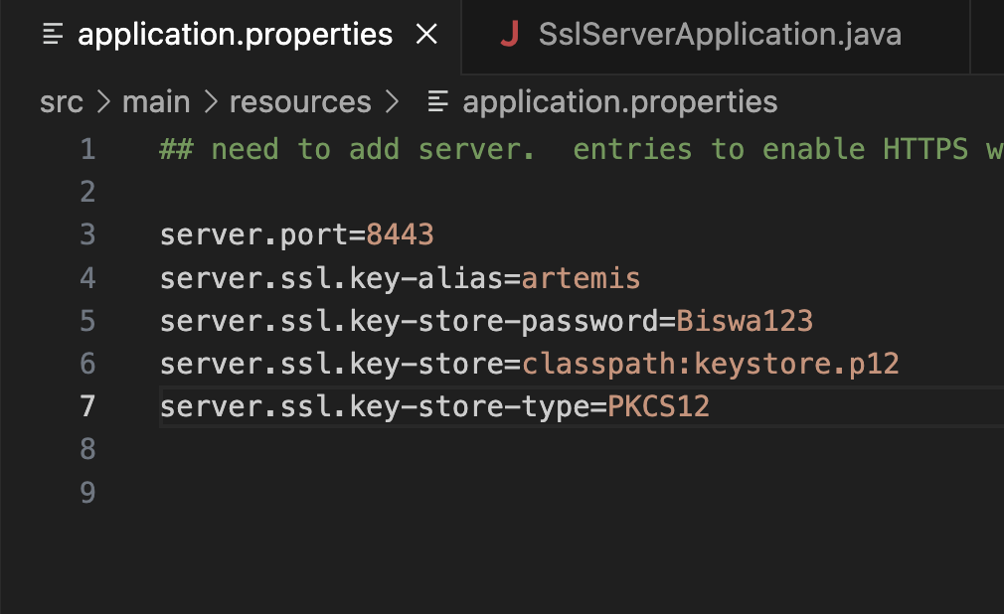

Summary

The code was updated in two main ways. First a SHA-256 checksum endpoint was added to the Java application so that data integrity can be verified. Second the application was configured to run over HTTPS using a self-signed SSL certificate.

These changes addressed the following security areas from the Vulnerability Assessment Process Flow:
- Cryptographic failures: SHA-256 hashing was added to verify that data has not been changed.
- Insecure data transfer: HTTP was replaced with HTTPS so all data is encrypted when sent over the network.
- Vulnerable dependencies: The OWASP Dependency-Check tool was run and confirmed that no new vulnerabilities were added by the refactored code.

The CVEs found in the report all come from the original Spring Boot 2.2.4 framework that was part of the starter project. They are pre-existing issues and not caused by any code written for this assignment.

Industry Standard Best Practices

How Best Practices Were Used
SHA-256 was chosen because it is recommended by NIST as a safe and modern hashing algorithm. It is widely used in browsers certificates and security software around the world. Using a well-known trusted algorithm means the code follows the same standards as real-world security systems.

The HTTPS setup follows OWASP guidelines for protecting data in transit. Configuring the server to only accept HTTPS connections means that no unencrypted traffic can reach the application. The keystore stores the certificate and private key securely so they are not exposed in the code.

The OWASP Dependency-Check tool was used to follow the practice of checking third-party libraries for known issues. This is a common step in secure software development and helps catch problems before they reach production.

Why This Matters for Artemis Financial
Artemis Financial works with sensitive financial data. If that data is intercepted or changed it could harm their customers and damage the company. By using HTTPS and SHA-256 the application now protects data both in transit and at the point of verification.

Following security best practices also helps Artemis Financial meet legal and industry requirements. Financial companies are expected to protect customer data under laws like the Gramm-Leach-Bliley Act. Having secure software shows that the company takes those responsibilities seriously.

